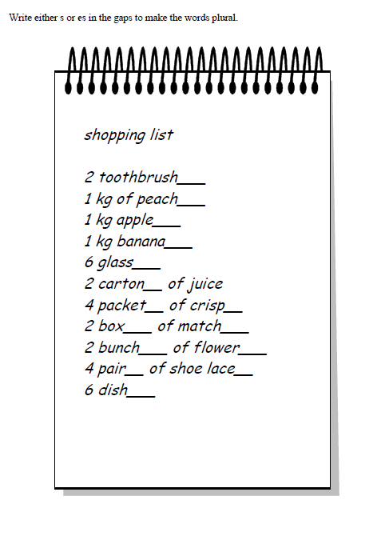Write s or es in the gaps to make the words plural. Now write your own shopping list! Careful with the spelling!